Republic of the Philippines

**CAVITE STATE UNIVERSITY**

**TRECE MARTIRES CITY Campus**

Trece Martires City, Cavite

Date: **February 23 – February 24, 2022**

Tasks:

1. Checking or filtering for the computers that is not working and working in the Computer Laboratory 1.
2. Planning the network cabling where to put the cables.
3. Creating straight through and cross over cable for the connection of different rooms in school such as Registrar, Library, AP room and many more.
4. Testing the cables if it is working using a LAN Tester.
5. Arranged the cubicles of the computers and cleaning the Computer Laboratory 1.
6. Assembly and Disassembly of computers in Computer Laboratory 1.
7. Assigned to study and create something using the HTML, CSS and JavaScript.

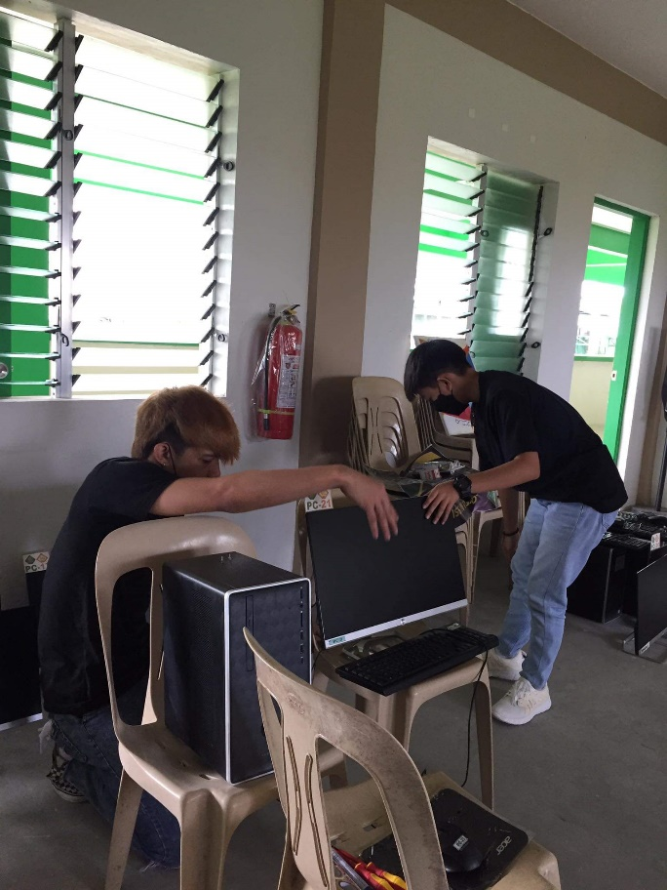

Figure 1. Checking for working and not working computers

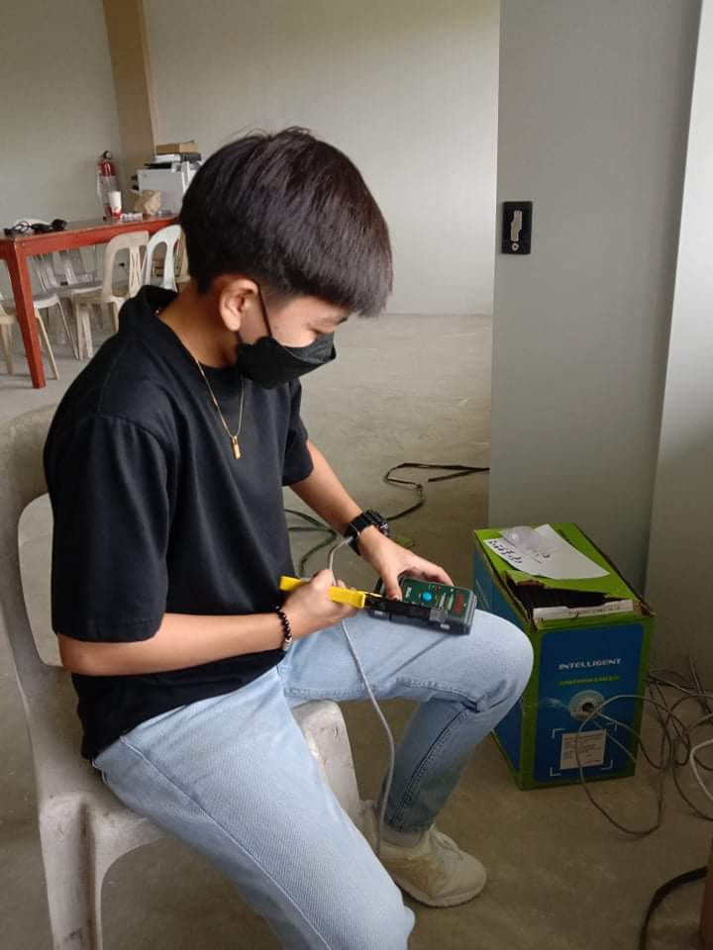

Figure 2. Testing the cable in LAN Tester

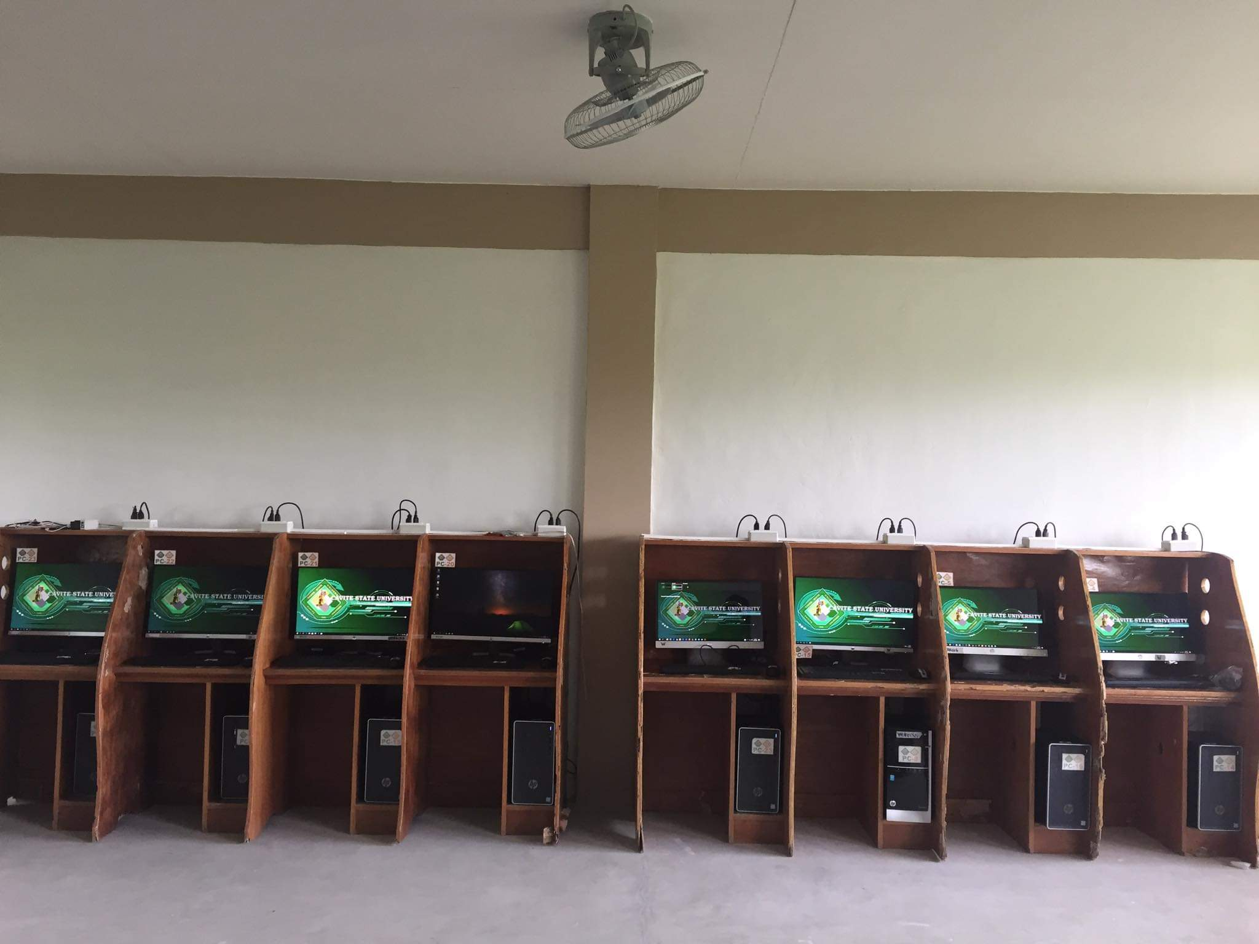

Figure 3. Computer Laboratory 1

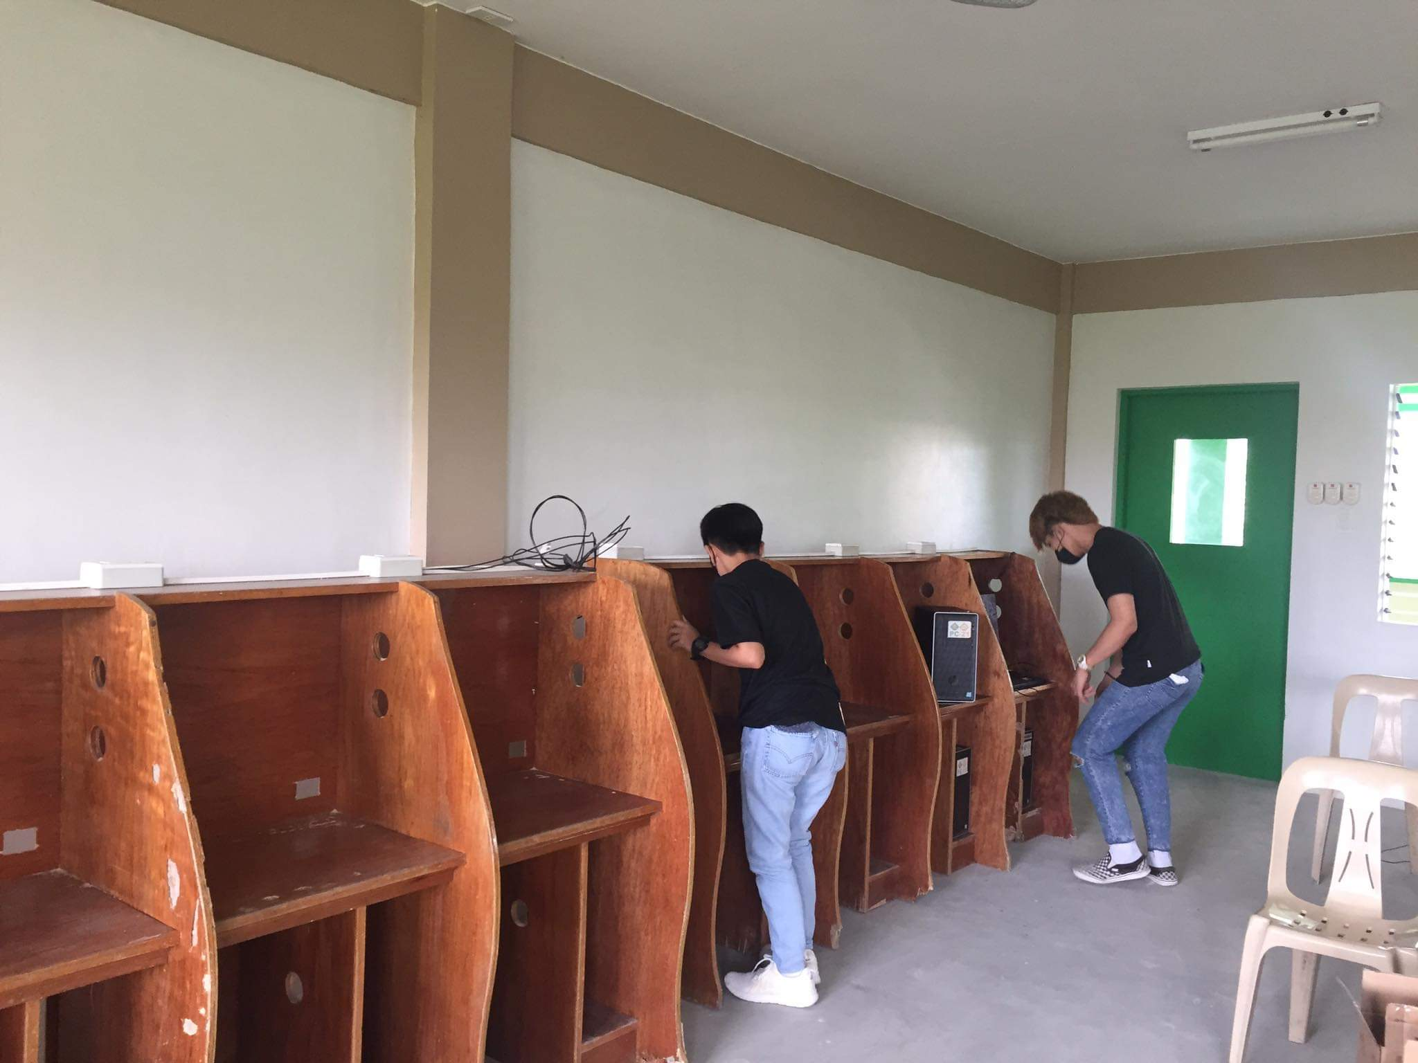

Figure 4. Arranged the cubicles in Computer Laboratory 1

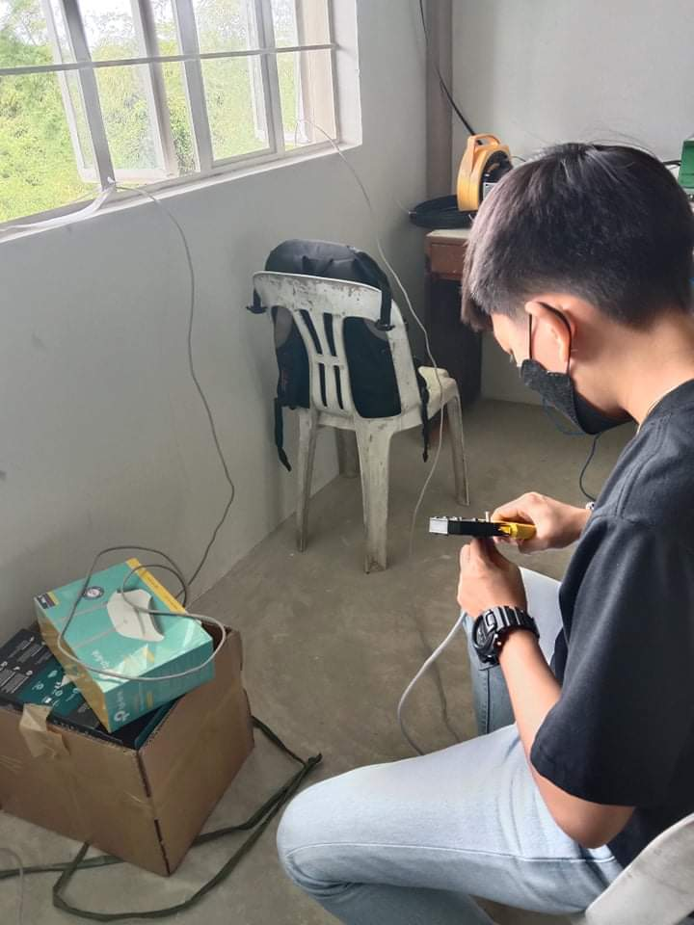

Figure 5. Crimping the category 5e cable

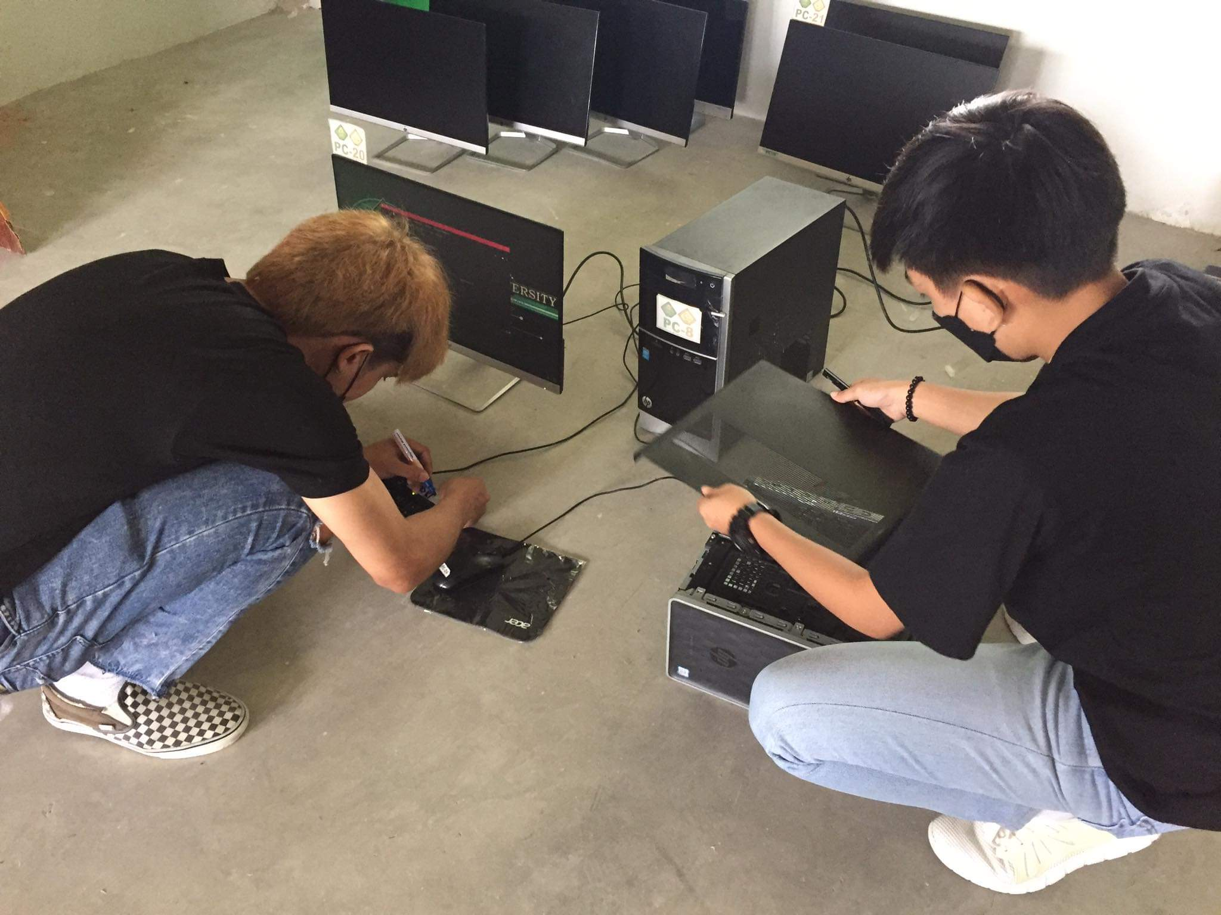

Figure 6. Checking the parts of the System Unit

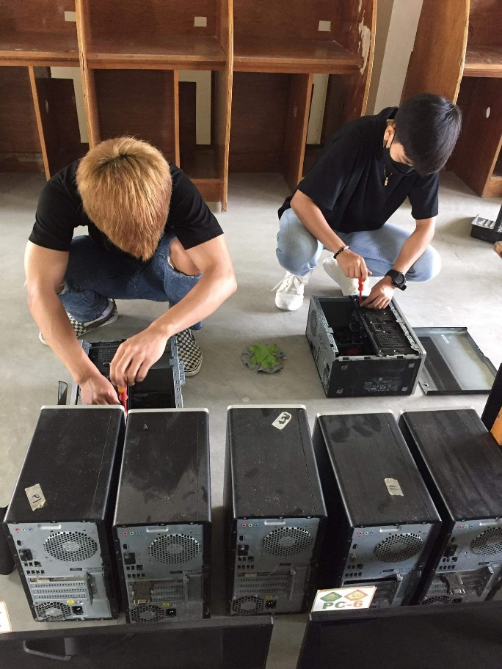

Figure 7. Assembly and Disassembly of computers

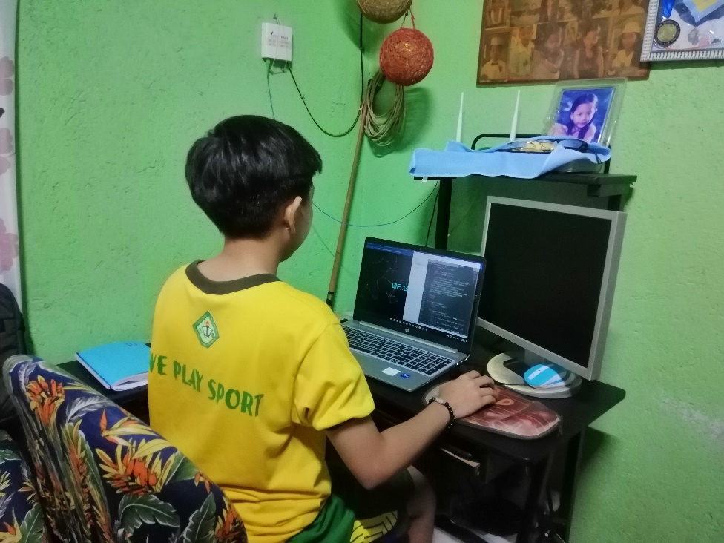

Figure 8. Creating HTML, CSS and JavaScript

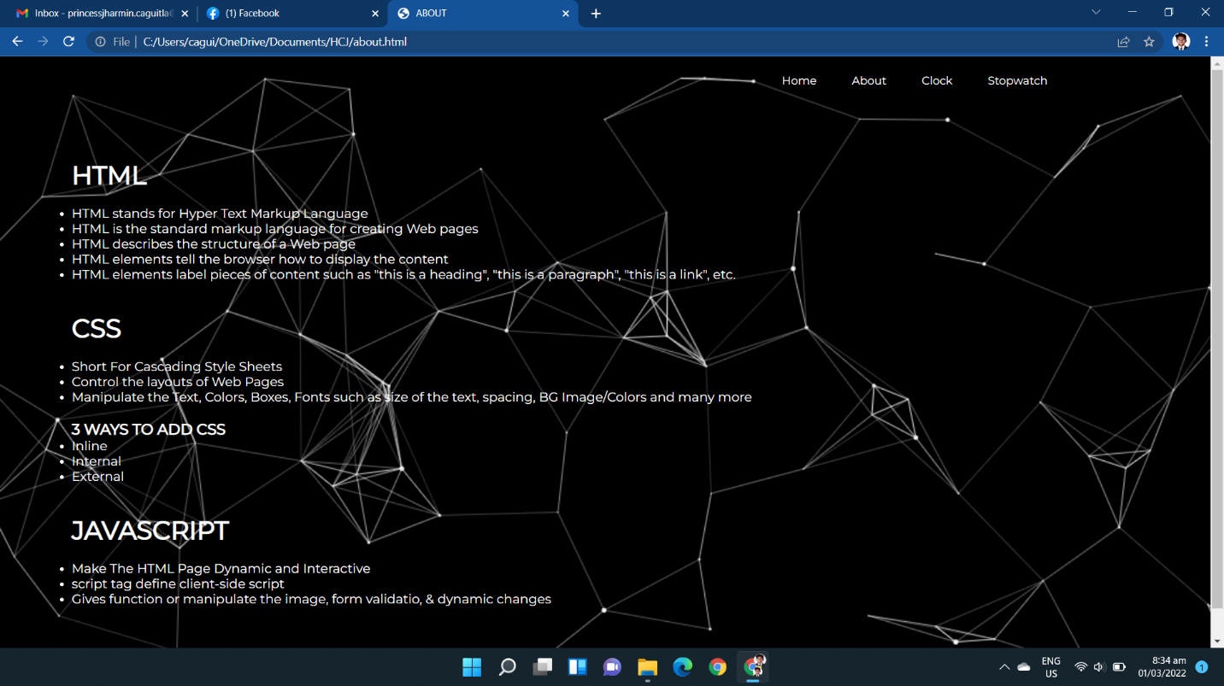

Figure 9. HTML, CSS and JavaScript about page

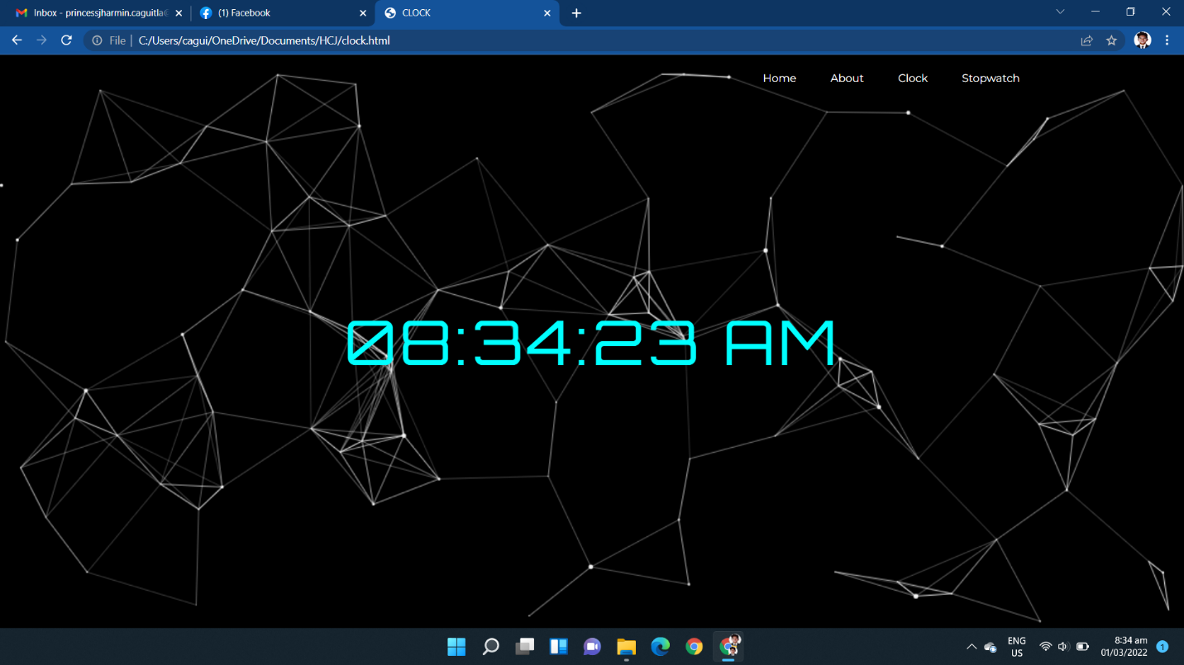

Figure 10. HTML, CSS and JavaScript digital clock page

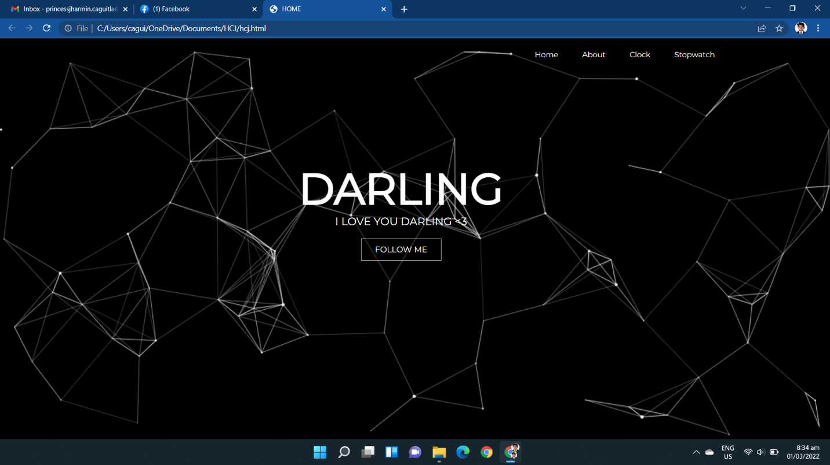

Figure 11. HTML, CSS and JavaScript home page

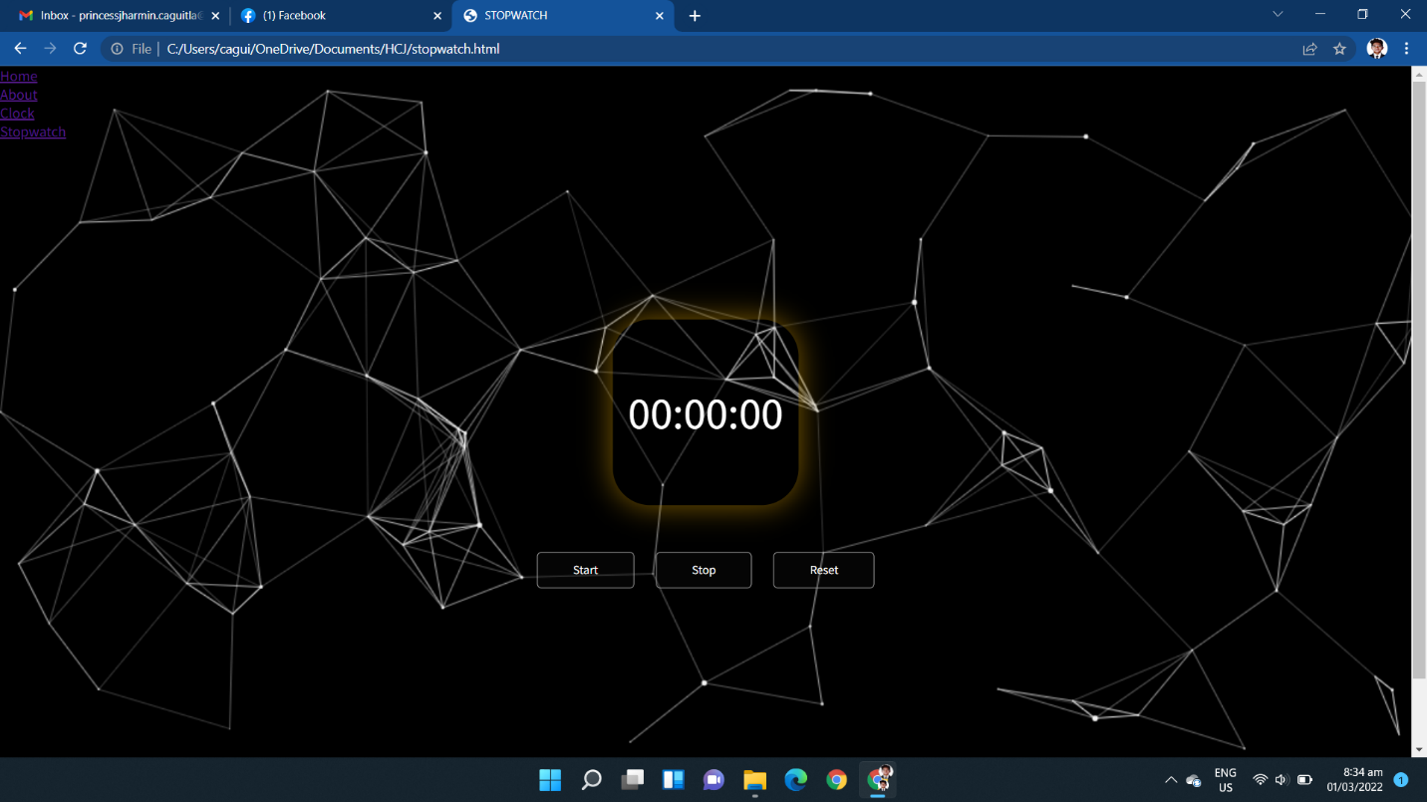

Figure 12. HTML, CSS and JavaScript stopwatch page

Prepared by: Approved:

**Princess Jharmin A. Caguitla** **Julie Ann C. Bucog**

Name and Signature of OJT Supervisor

**March 4, 2022**

Date **Jericho Jover V. Magpantay**

Supervisor